**User Guide for Food-Chain Consumer**

This program is meant to be used by customers at the final location of the food supply chain, normally supermarket to check on the food supply chain.

**Requirements:**

* Valid Product QR code must present
* Network connection must be available
* Network connection must allow access to <http://174.140.168.136:6876/> (NXT wallet peer)

**Extra notes:**

* “res/raw/database.txt” of this app acts as a local database to check for location information (hardcoded in JSON)
* Location codes used at Local Java Server (e.g. Kch.txt, Mri.txt and Btu.txt) must be registered in “res/raw/database.txt” of this app
* In real-world implementation, there should be an online database storing the registered location information

**How to build the app:**

1. Install/Update latest Android Studio IDE
2. Open Android Project (ConsumerApp)

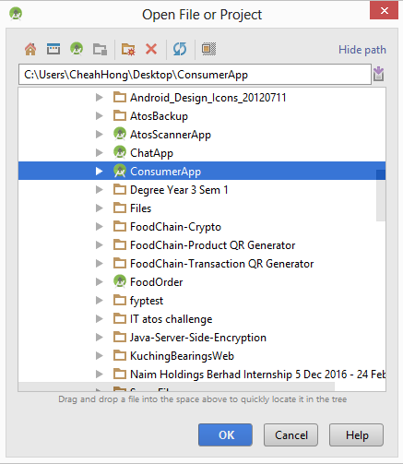

1. Run the project

**Devices tested on:**

* Samsung Galaxy S4 (Android Version 5.0.1)
* Samsung Galaxy A5 2016 (Android Version 6.0.1)

**External API:**

* NXT API

**Open source library:**

* Volley(Asynchronous HTTP request)
* BouncyCastle (Java Cryptography)
* Zxing (QR scanner)

**Use Cases:**

1. Customer goes to a supermarket to buy a package of apple
2. Customer is unsure of the origin of the apple (imported)
3. Customer sees the QR code and proceeds to open Food-Chain Consumer App
4. Customer scans the QR code using the Food-Chain Consumer App
5. Customer sees the apple supply chain